Lab 1 Assignment - Higher-Order and Recursion Functions in OCaml

Group #: 3
Joey Issa - 300219818
Garrett Winslow - 300149981
Yannick Vaillancourt - 300226628

Q1
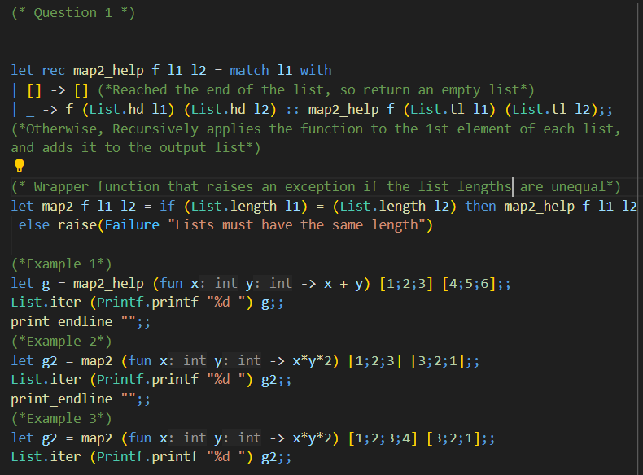
Output:
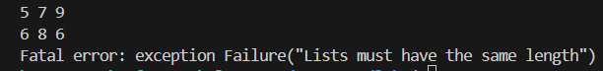

Q2
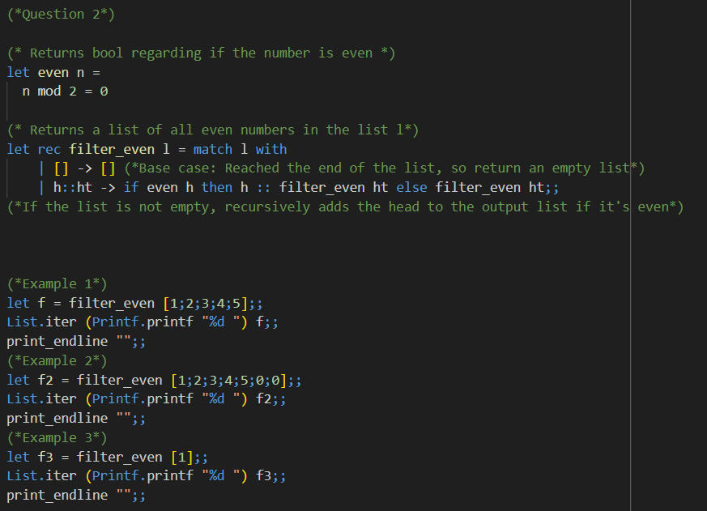
Output
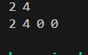

Q3
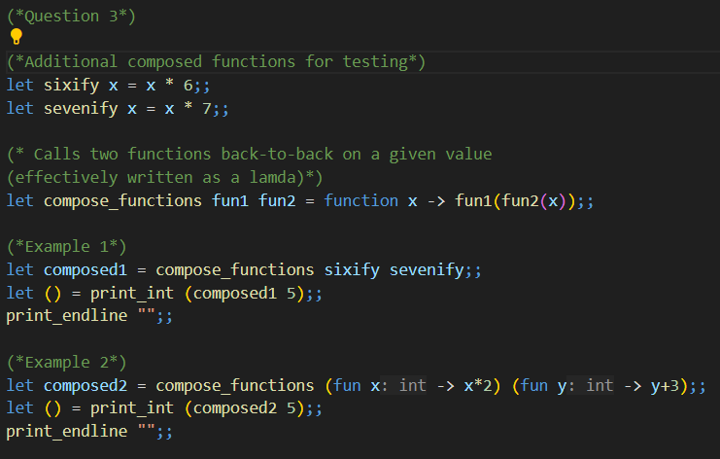
Output:
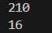

Q4
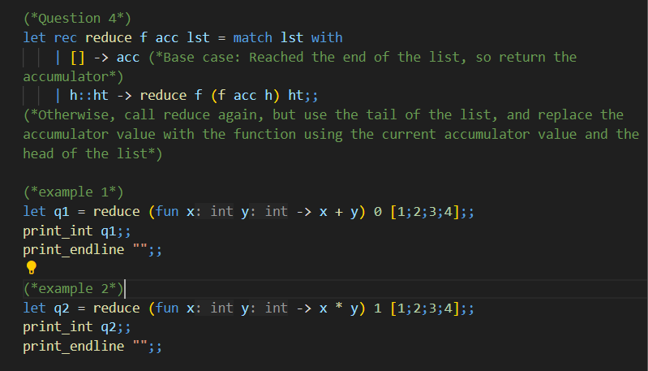
Output:
